Language Research

Full Name: Meet Maheta

Course Name: CST8333

Assignment Title: Programming Language Research Project - Research Assignment 1

Submission Date: May 18, 2024

Language Research

**Website 1:**

**APOLLO Solutions**

**Description:** Apollo Solutions ranks programming languages based on industry demand and developer interest, providing insights into current trends and usage.

**Reputable Source:** Apollo Solutions is known for its comprehensive educational resources and market research, making it a credible source for programming language trends.

**Website 2:**

**InvoZone**

**Description:** InvoZone provides a ranking of programming languages based on industry reports and developer surveys, highlighting the most sought-after skills in the tech market.

**Reputable Source:** InvoZone is recognized for its in-depth market research and industry analysis, making it a trustworthy source for understanding programming language trends and demands.

**Website 3:**

**CoderPad**

**Description:** CoderPad ranks programming languages based on data from technical interviews and coding assessments, reflecting practical usage in hiring processes.

**Reputable Source:** CoderPad is a widely-used platform for technical interviews, providing reliable data on programming languages that are in demand by employers.

# **References:**

|  |  |
| --- | --- |
| [1] | "The best programming languages to learn in 2024," Apollo solutions, 13 Oct 2023. [Online]. Available: https://www.apollo-solutions.com/resources/blog/the-best-programming-languages-to-learn-in-2024/. |
| [2] | "Copying is not allowed on this webpage," Invozone, 16 Jan 2024. [Online]. Available: https://invozone.com/blog/top-10-programming-languages/. |
| [3] | "Most Popular Programming Languages in 2024," CoderPad, 17 jan 2024. [Online]. Available: https://coderpad.io/blog/hiring-developers/top-10-in-demand-programming-languages/. |

Language Selection

**Programming Language to Study:**

**Chosen Language:** Python

**Reasons for Study:** Python is popular, versatile, and known for its simplicity and readability, making it an excellent choice for both beginners and experienced developers.

It has a vast ecosystem of libraries and frameworks that support a wide range of applications, including web development, data science, artificial intelligence, and automation.

**Career Goals Alignment:** Learning Python aligns perfectly with my career goals in data science and machine learning.

Python is the most widely used language in these domains, with powerful libraries such as NumPy, Pandas, and TensorFlow that are indispensable tools for data analysis and building machine learning models.

Unit Testing Research

**Website 1**

**Software Testing Help Documentation**

**Description:** Software Testing Help provides comprehensive tutorials and guides on various unit testing frameworks for Python, including PyTest and Unittest.

**Website 2**

**BrowserStack Documentation**

**Description:** BrowserStack offers detailed documentation and best practices for using different unit testing frameworks in Python, focusing on integration with continuous testing environments.

**Chosen Framework:** PyTest

**Reason for Choosing:**

* **Simplicity and Ease of Use:** PyTest is known for its user-friendly syntax and ease of use, making it accessible for both beginners and experienced developers.
* **Powerful Features:** PyTest provides advanced features like fixtures, which allow for setup and teardown of testing environments, and parameterized testing, which enables the running of multiple test cases with different inputs.
* **Extensibility:** PyTest supports a wide range of plugins that extend its functionality, allowing for integration with other tools and frameworks.
* **Community Support:** PyTest has an active and supportive community, with extensive documentation and resources available online.

# **References:**

|  |  |
| --- | --- |
| [4] | "Copying is not allowed on this webpage," Invozone, 16 Jan 2024. [Online]. Available: https://invozone.com/blog/top-10-programming-languages/. |
| [5] | "Most Popular Programming Languages in 2024," CoderPad, 17 jan 2024. [Online]. Available: https://coderpad.io/blog/hiring-developers/top-10-in-demand-programming-languages/. |

Development Tools: Platform, Tool Availability, Licensing

**Operating System**

**Details:** Operating System: Windows 11 Pro Version 21H2 Build 22000.318

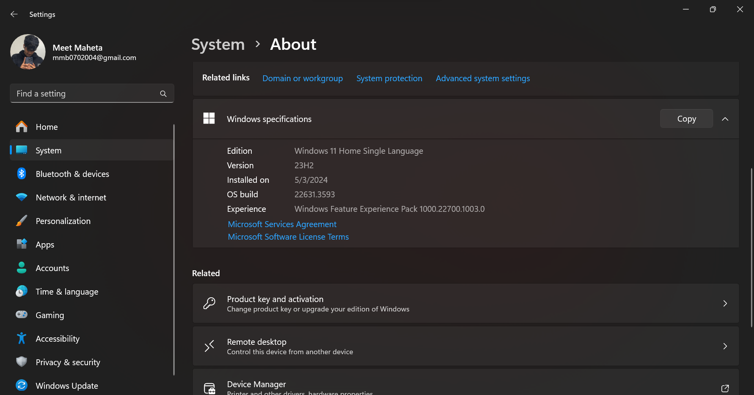

**Programming Language**

**Details:** Python 3.12.3

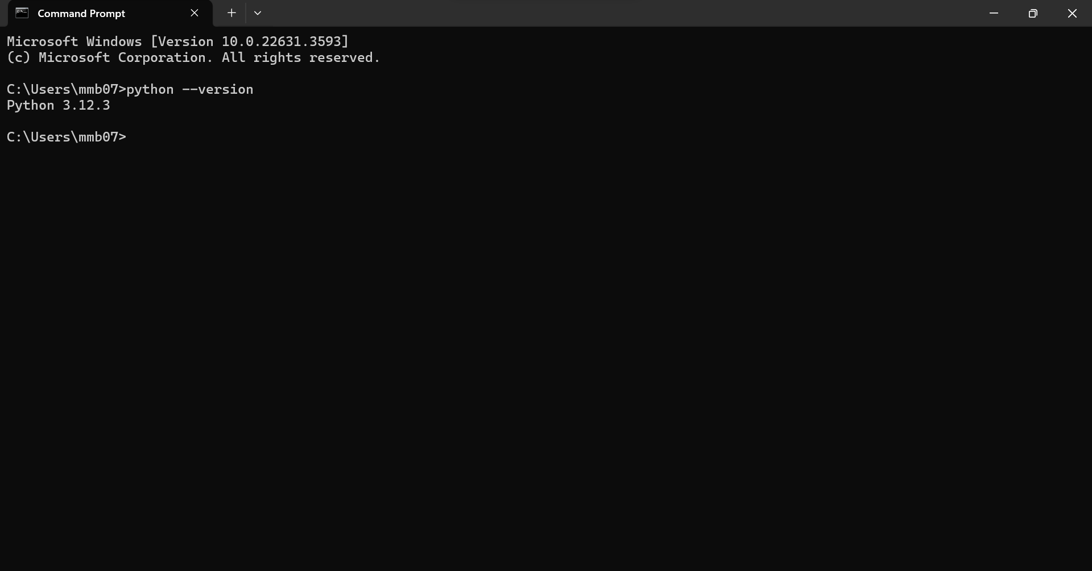

**Integrated Development Environment (IDE)**

**Details:** Visual Studio Code 1.89.1

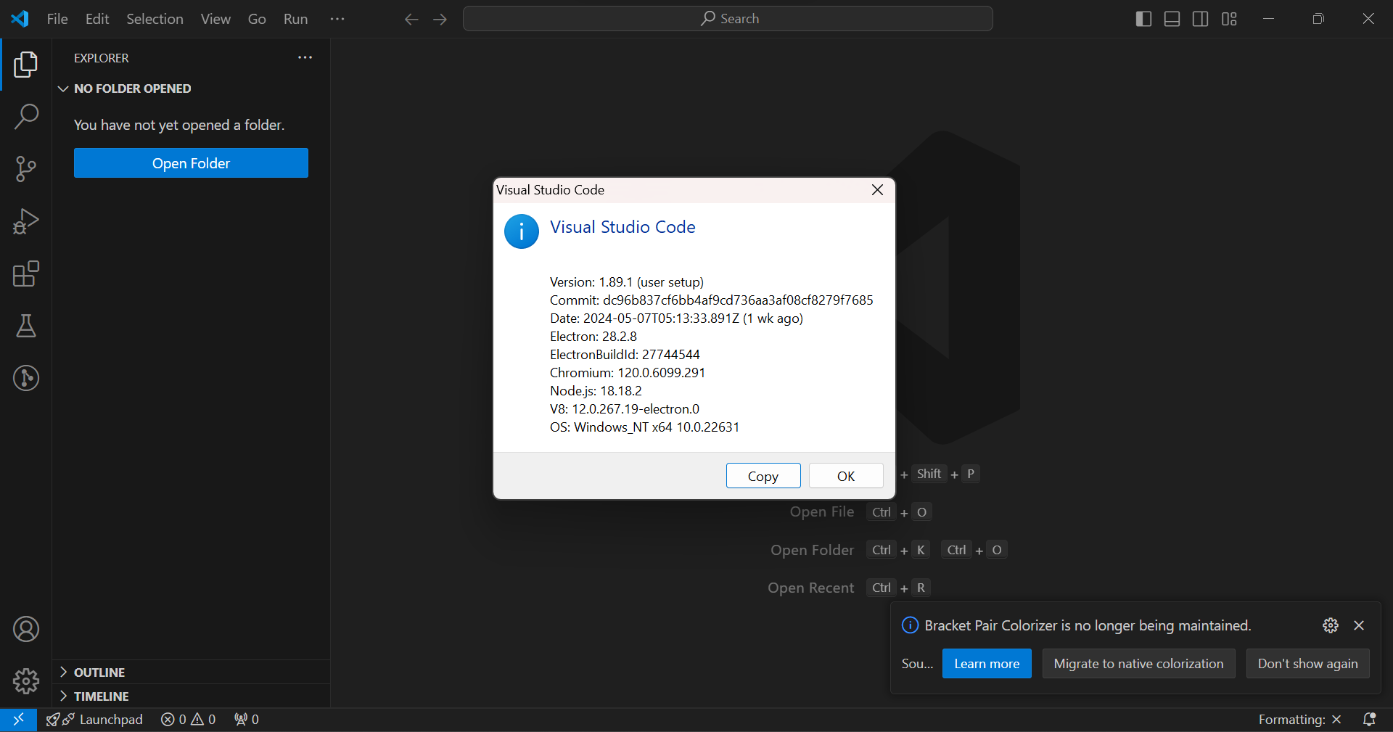

**Software Licensing**

Details: All selected development tools are free for individual use.

Visual Studio Code is available under the MIT license, and Python is available under the Python Software Foundation License.

Visual Studio Code: Free for use under the MIT license.

Python: Free for use under the Python Software Foundation License.

WBS and Gantt Chart for Practical Project Part 1

